**Transportation Shop Tool ID**

/63 marks

Name: ____________________________________________

Go through and identify the following tools and answer the questions that go along with some of them:

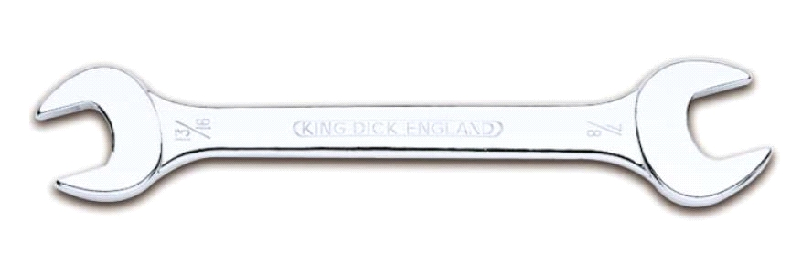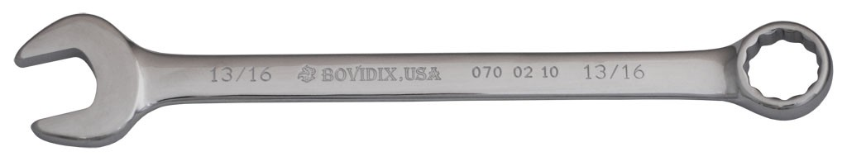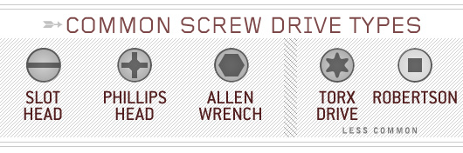

____________________ _____________________ _____________________ _______________________ ______________________

____________________________ _____________________________

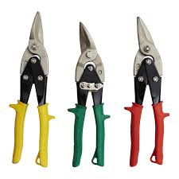

These are called: _______________ ___________ and what direction do they cut?

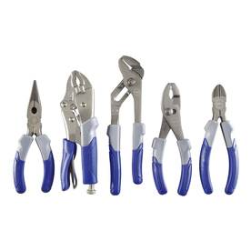

____________________________

____________________________

____________________________

(yellow)____________________________

(red)____________________________

____________________________

____________________________

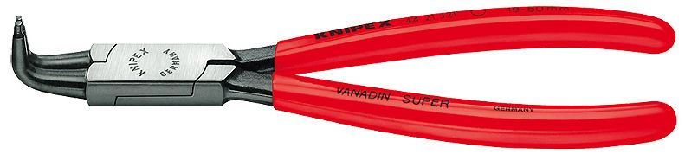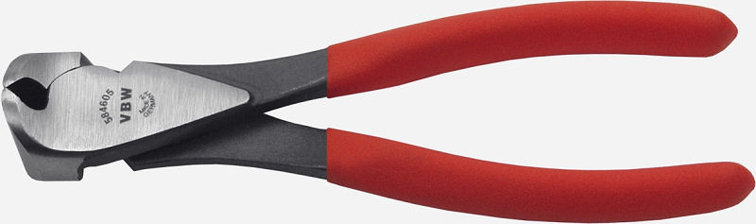

(green)____________________________

_______________________________

_______________________________

____________________________

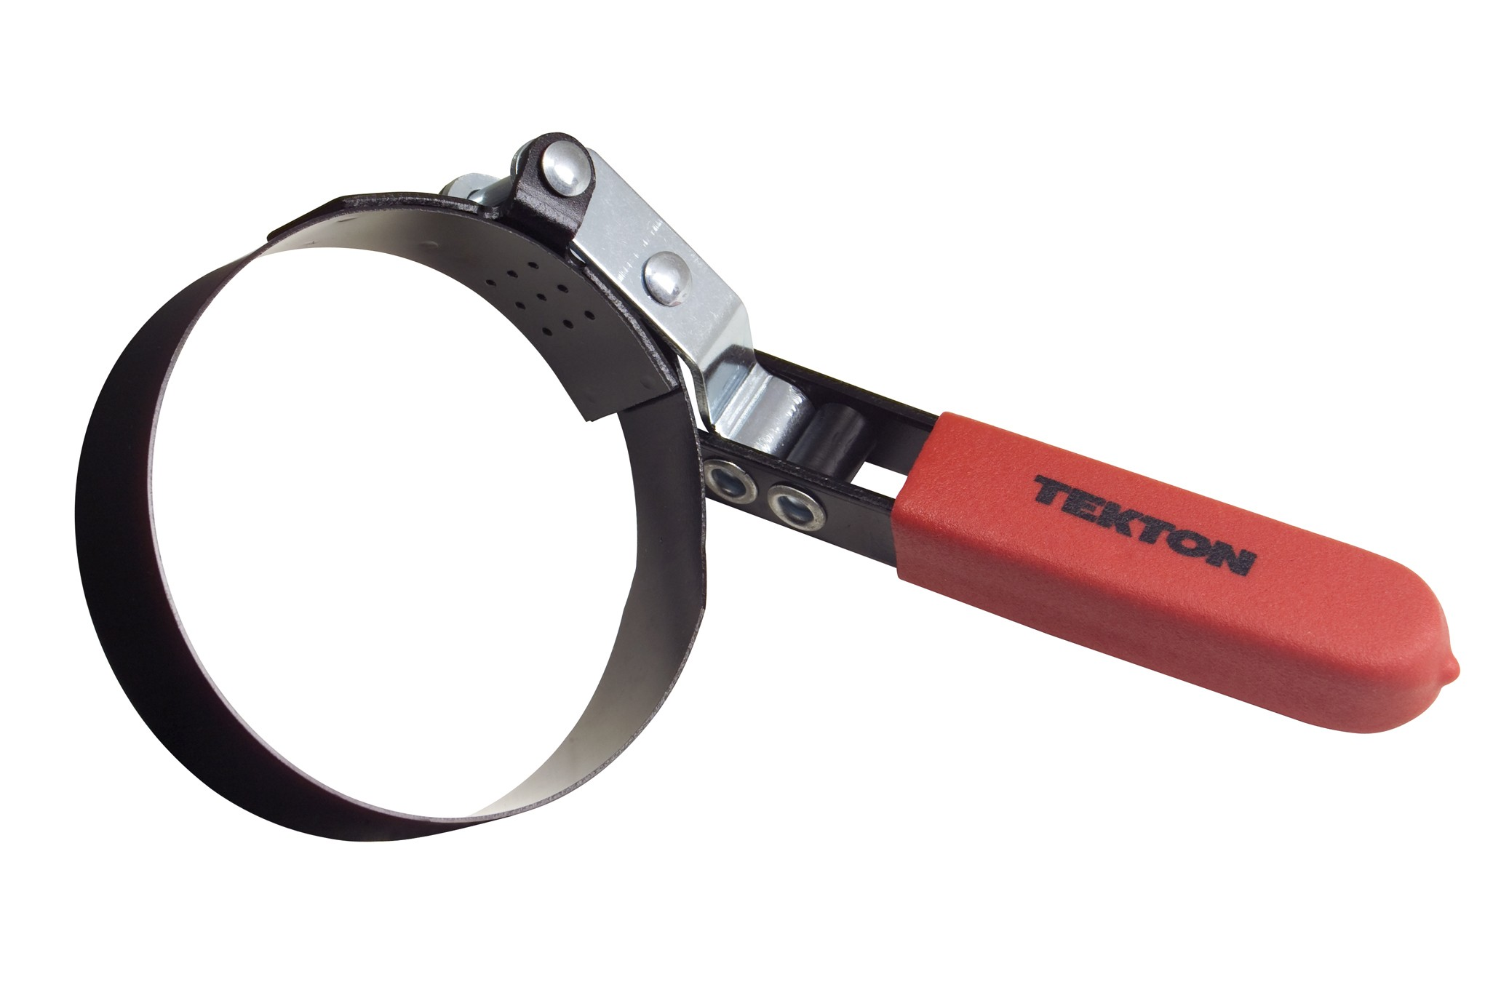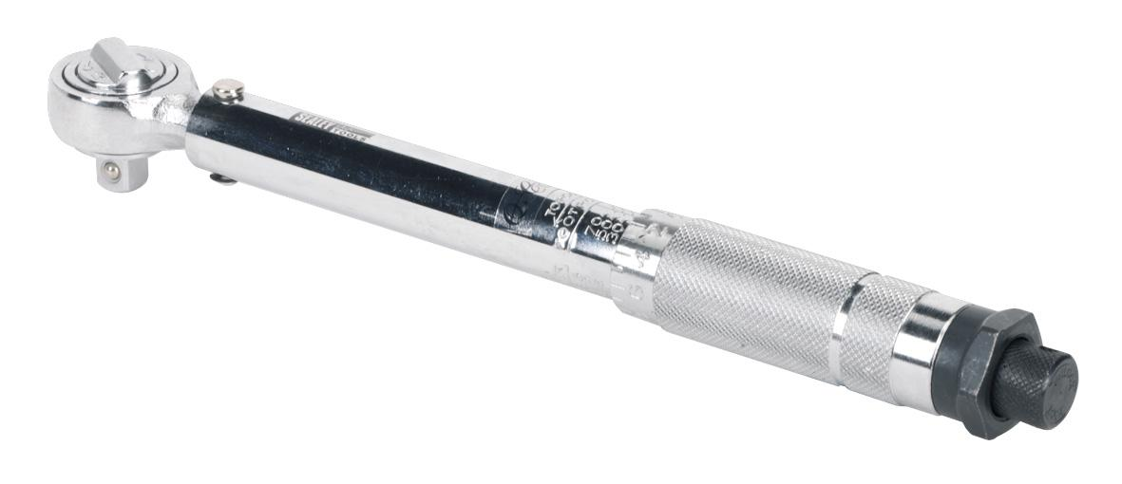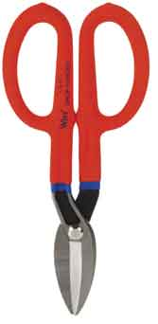

And what does the above do?

___________________________________

___________________________________

_______________________________

_______________________________

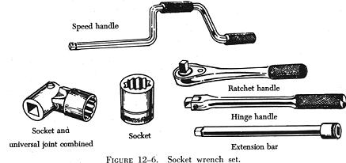

______________________________________

_______________________________

______________________________________

_______________________________

______________________________________

_______________________________

___________________________

_______________________________

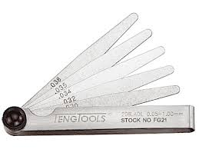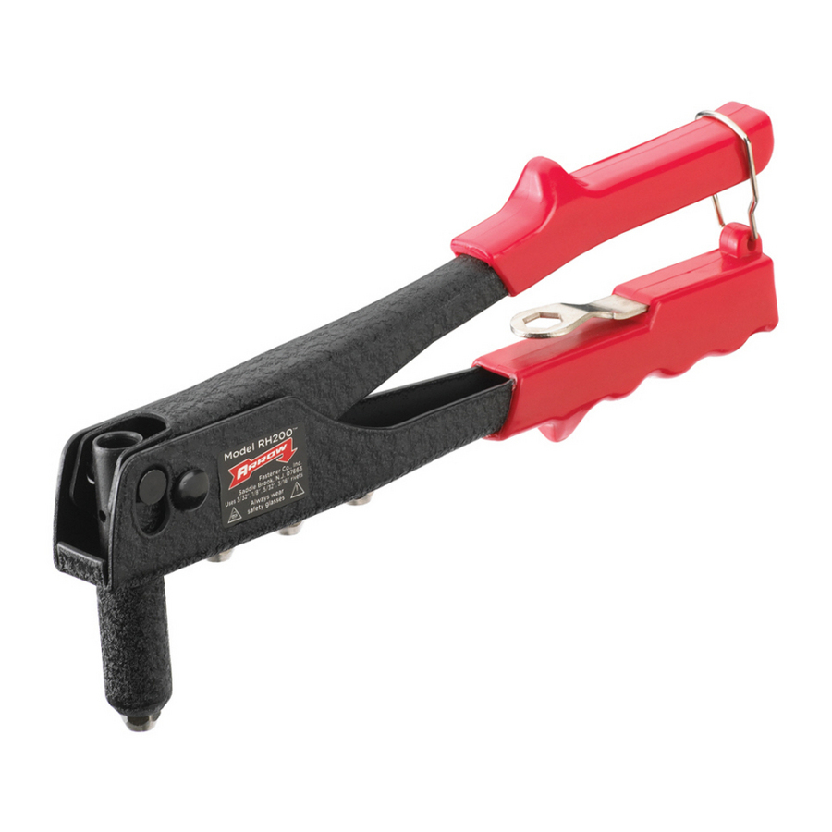

___________________________

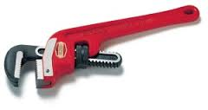

And what does the above do?

___________________________________

___________________________________

_________________________________

_______________________________

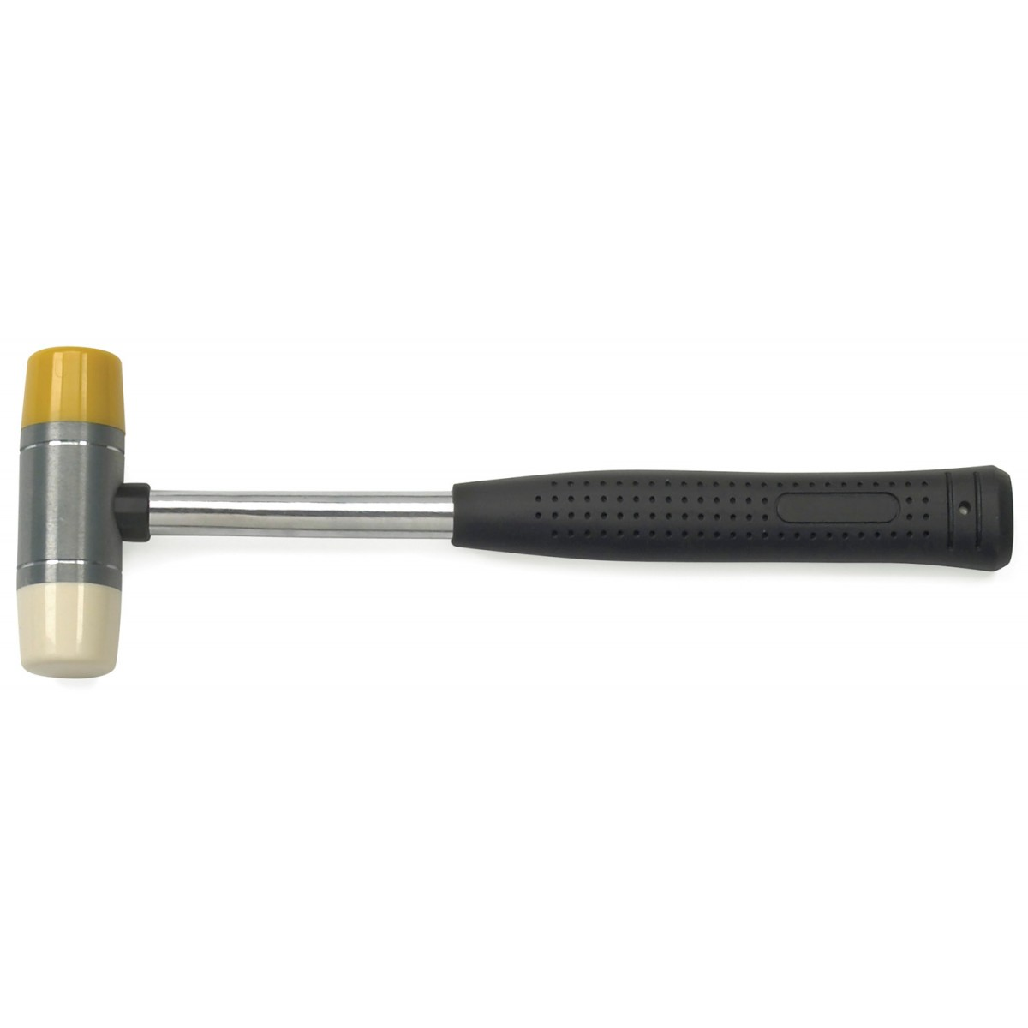

_______________________________

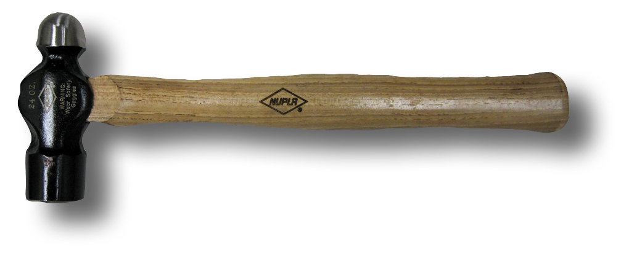

_____________________________ And why would you use this?

_________________________________________

_______________________________

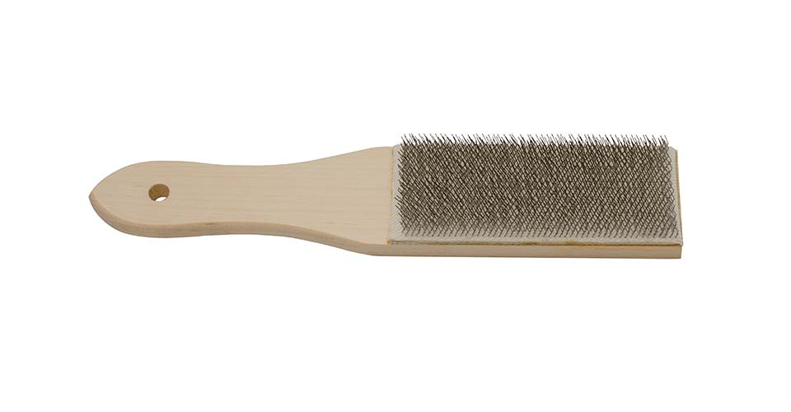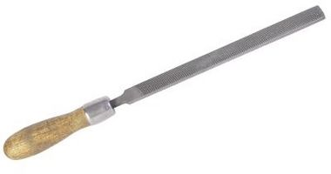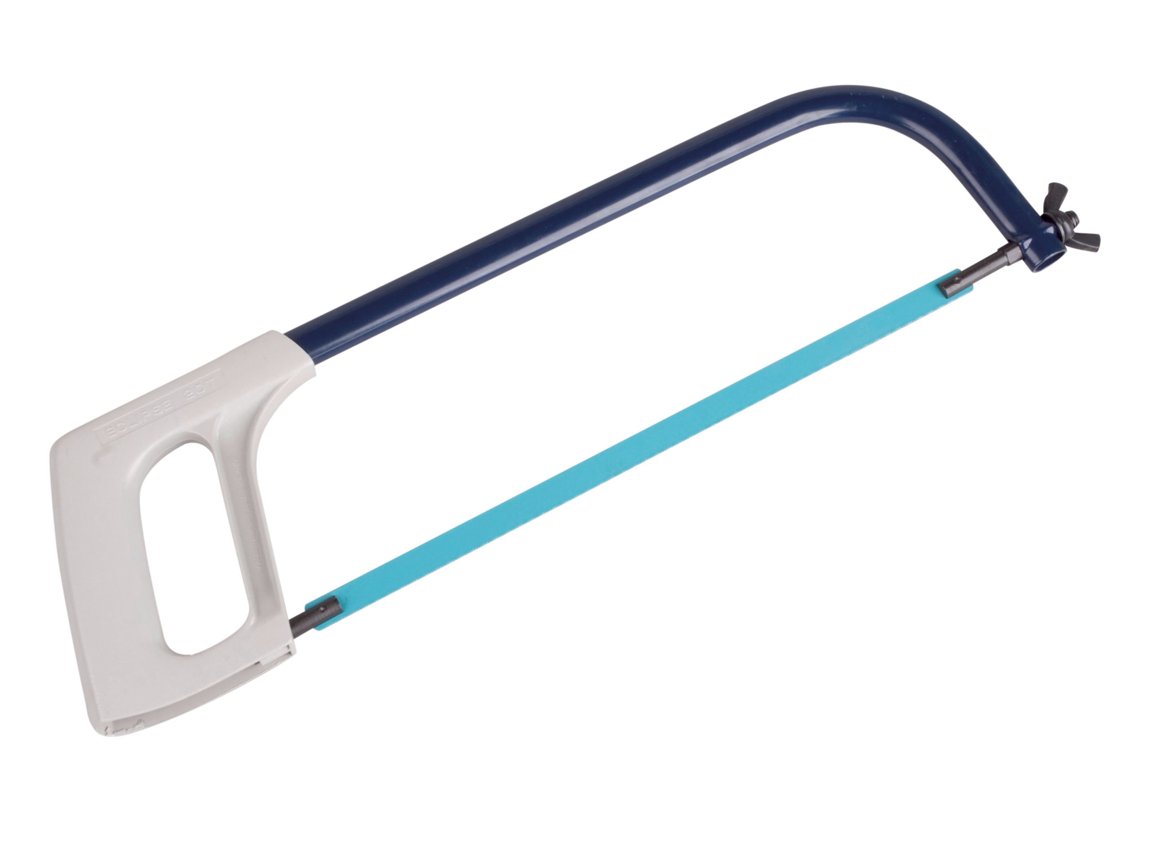

_______________________________

_____________ ____________

_______________________________

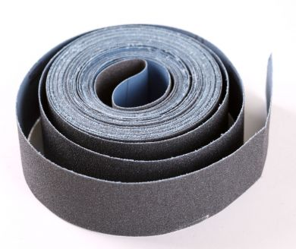

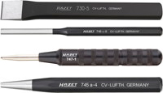

_______________________________

_______________________________

_______________________________

_____________ ________________

_______________________________

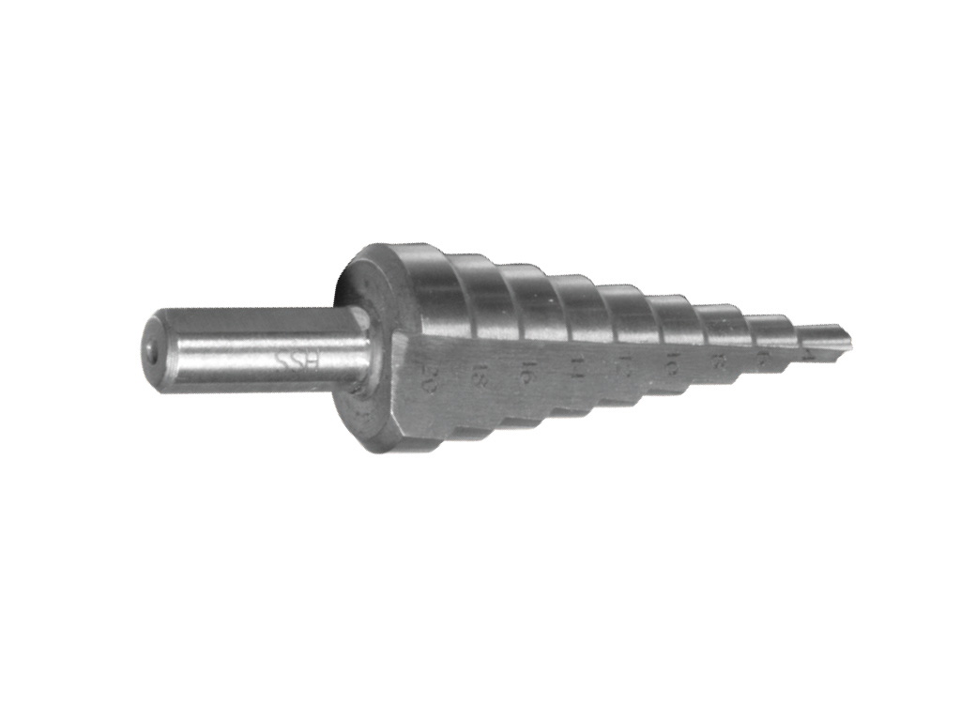

Name type of drill ***and*** for what material(s)





